Drinkstone Parish Council
Lest we forget Statues

As per the council objectives for 2022/23 I have looked into the viability and cost of 4 “Lest we Forget” statues to be used in the village every year during the month leading up to Remembrance Sunday.
Drinkstone has a proud history of acknowledging our fallen dead and in addition to the memorials in the church recognising those who gave their lives in WW1 and 2 the Parish Council should wish to create a further permanent reminder to those who have perished subsequently. The Royal British Legion have created semi silhouettes to act as a reminder of the fallen for use specifically around Remembrance Sunday. The council received an anonymous donation of circa £770 earlier this year and after discussion with the donor, who is fully supportive of the idea, I propose that the PC purchase 2 pairs of the unknown Tommy Statues to be displayed annually from 1st October.
1 pair by the phone box next the Church on the Street and 1 pair by the Village sign on the junction of Gedding Road and Green Close.
The Statues are constructed from Aluminium Composite (3mm thick)
Size: | 1.47m- 4ft 10
Weight: | 4kg
Suitability: | Can be installed in the ground using included angle irons, or mounted on the side of a wall or building using wall plugs and fixing screws (not included.)  Suitable for permanent use, or easily removed and re-installed for events such as Remembrance or VE Day.
Assembly: | Self-assembly with included assembly guide using pre-cut holes and fixings. Very easy (5 mins).
Contents: | - 1 x Unknown Tommy Statue  - 1 x 6ft 30mm face Angle Iron  - 1 x 3ft 30mm face Angle Iron  - 5 x Locking nuts & bolts  - 5 x Washers & bolt caps
Unknown Tommies are light, easy to position and durable, serving as a very impressive and permanent reminder of our nation's fallen soldiers and those who continue to serve.

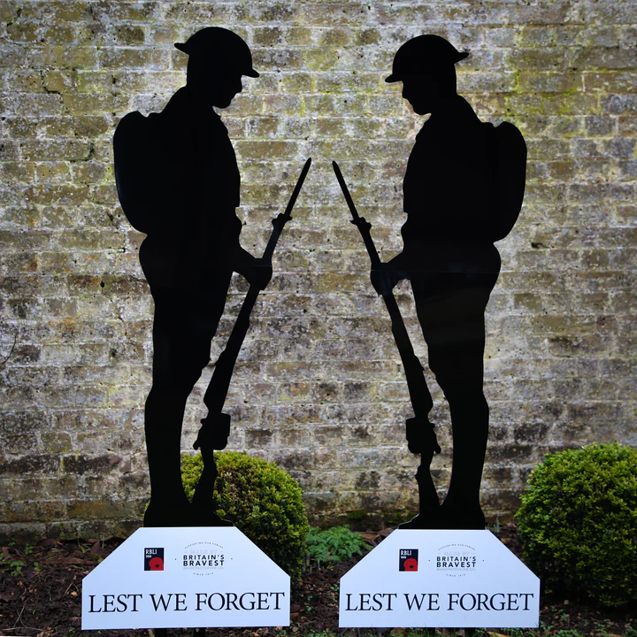

The cost for 2 pairs is £700 with an approximate 3 to 4 week lead time from placement of order.

Proposal
Drinkstone Parish council purchases 2 x pairs of Lest we forget statues using money donated to the PC for us annually in the village to acknowledge our fallen and commemorate Remembrance Sunday.

